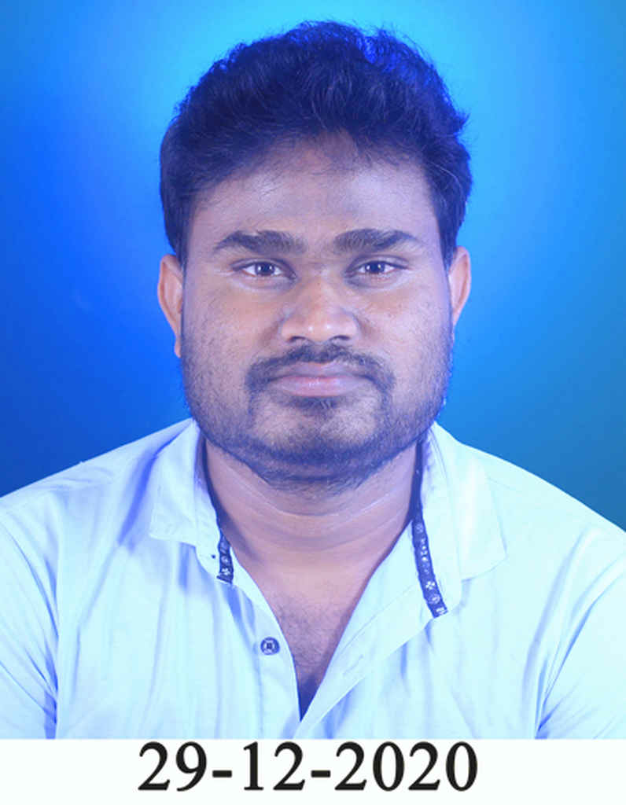

**Personall Details-**

SATHISH GOSKI

Date of Birth: 02-01-1987

**Mobile :- +917498317136**

**WhatsApp number 8919562836**

Languages Known:Hindi,Telugu,English,Marathi

Sex – Male

Marital status – Single.

Hobby - Cricket and Reading books

**Email :shaurya0072010@gmail.com.**

**EDUCATION: M.SC (CHEMISTRY) B.Ed**

**Objective:**

* To be part of organization that gives the opportunity to learn & update my knowledge & skill to be part of a team, that dynamically works towards the growth of organization.

**Skills**

* Extensive hands-on experience in the practice of Chemistry and solid grasp of its theories
* Comprehensive knowledge and understanding of the subject to create, execute, and analyze student assessments.
* Outstanding ability to bring about and maintain high academic standards Ability to work closely and collaboratively with the school administration.
* Exceptional leadership qualities and amazing ability to maintain order in the classroom
* Proficiency in a wide range of teaching methods and techniques In-depth knowledge And experience in developing unique lesson plans suited to any number of students with special needs.
* Superb organizational and time management skills Unquenchable passion and drive to succeed.
* First-rate interpersonal and communication skills to maintain great relationships with colleagues

**Computer Skills**

* Basic knowledge of computer as well as certification in MSC-IT
* A good knowledge of cyber world.

**Education Profile:**

| **2011**: **M.Sc. (Organic Chemistry)**  Department of Chemistry, Hislop College affiliated to   1. T. M.N.U University, Nagpur   **2007: B.Sc.**  Shivaji College, Affiliated to  R. T. M. Nagpur University, Nagpur   1. **B.Ed in science**   Green heaven B.Ed college ,  Nagpur university |
| --- |

**Work Experience:**

**IGCSE chemistry teacher**

**NISA school myanmar ( IGCSE)**

**April 2022 to present**

**Handling IGCSE chemistry classes for grade level 9 to 11 .**

**Conducting practical based experiments .**

**Act as head of science department.**

**Handling chemistry Olympiad and practical experiments .**

**PGT chemistry ( Consultant) -July 2021 to march 2022 ( CBSE board)**

**Mount litera zee school nagpur**

Prepare and deliver lectures to grade 6 to 11 students on

topics such as organic chemistry, analytical chemistry,

and chemical separation.

Supervise students' laboratory work.

Evaluate and grade students' class work, laboratory Performance,Assignments.

**Freelancer (Online Tutor ) -- June 2020 to June 2021 ( CBSE and ICSE)**

* Taking classes for grade level 6 to 10 ( Cbse and Icse students) by preparing conceptual ppt and enhancing learning curve with better approach

**Knowledge planet Dubai --- April 2018 to April 202**0 ( **CBSE and IGCSE BOARD )**

* Handled classes on subjects relating to Chemical and Physical Properties and

compositional changes of substances.

* Part of new pilot project to introduce new Technology into the classroom for a better learning experience.
* Promoted student engagement by using a Broad range of teaching techniques and

methods in order to inspire and motivate learning.

* Created and implemented daily lessons on Standard Chemistry Topics

Developed a healthy and fun learning environment for the students in the classroom.

* Acted as team coach for several inter school Chemistry contests and supervised students involved in similar events.
* Offered after-school tutoring for students who were having trouble keeping up in class.

**Sherwood public school (ICSE BOARD )( Hyderabad) --June 2015 to Feb 2018**

* Prepare and deliver lectures to grade 8 to 12 students on

topics such as organic chemistry, analytical chemistry,

and chemical separation.

* Supervise students' laboratory work.
* Evaluate and grade students' class work, laboratory Performance, assignments.

**Suyash central school ( CBSE board)**

**( solapur) -- Nov.2011 to may 2015**

* Prepare and deliver lectures to grade 8 to 12 students on

topics such as organic chemistry, analytical chemistry,

and chemical separation.

* Supervise students' laboratory work.
* Evaluate and grade students' class work, laboratory Performance,Assignments.

**Job Description-**

* Worked as a lecturer for Applied Chemistry Enhance student’s chemistry knowledge
* Prepared students for future planning towards their goal.
* Regularly demonstrate and supervise theory and practical for undergraduate students,Teaching human values

**Industrial experience.( internship)**

* Has experience of 6month as a chemist in IRSL NAGPUR January 2011 to August 2011.

I hereby declare that the above particulars are true to the best of my belief and knowledge.